SESSION 2 - NumPy Intermediate (Part 2: Indexing, Slicing, Broadcasting)Topics Covered:Indexing in 1D, 2D, and nD arraysSlicing arrays: [:], [start:end], [start:end:step]Selecting rows & columnsBoolean indexingFancy indexingBroadcasting rulesScalar-to-array broadcastingArray-to-array broadcastingPractical examples:Masking out negative valuesBroadcasting for feature scaling.

1.Create a 2D NumPy array representing the ratings (out of 5) given by 4 users to 5 different food items on Zomato. Use slicing to extract the ratings given by the second and third users only.
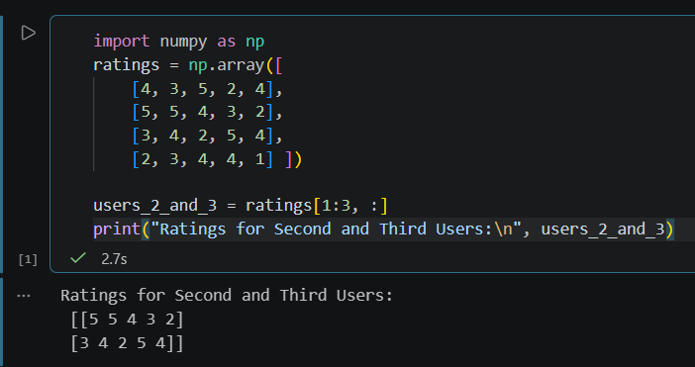

2.Given a NumPy array of daily steps tracked for 10 days, use boolean indexing to select only the days where the steps were greater than 8000. Use an array like steps = np.array([7500, 8200, 9000, ...]) and apply a boolean condition.
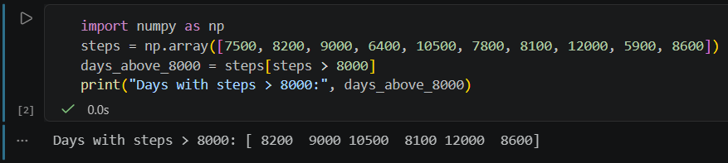

3.Create a NumPy array of IPL team scores for 8 matches. Use fancy indexing to select the scores from matches 2, 5, and 7, and print them.
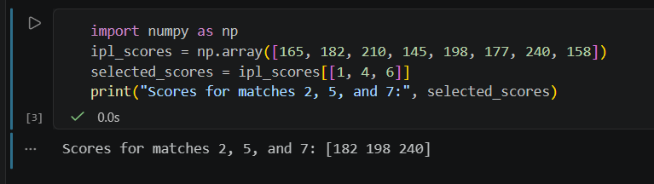

4.Suppose you have a NumPy array of product prices from Flipkart. Use broadcasting to apply a 10% discount to all prices and print the new array. Do not use any loops.
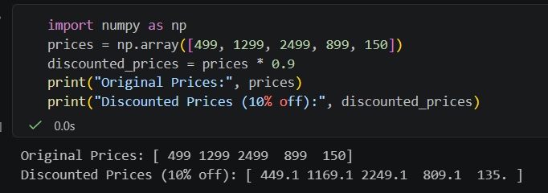

5.Given a NumPy array of user ratings (can be negative, zero, or positive) for songs on Spotify, use boolean masking to set all negative ratings to zero, keeping other ratings unchanged.
